Use this form to request addition of a new event on the mgofmc.org website.
Ensure you have the necessary approvals before sending this form.
- Send form to webmaster@mgofmc.org
- Please allow 3-5 days for the event to be added to the site.
Please only enter the requested information in the table below. If you have additional information you want to relay (or display on the event page) please use the space below the table.
Sample to understand how your event will display:
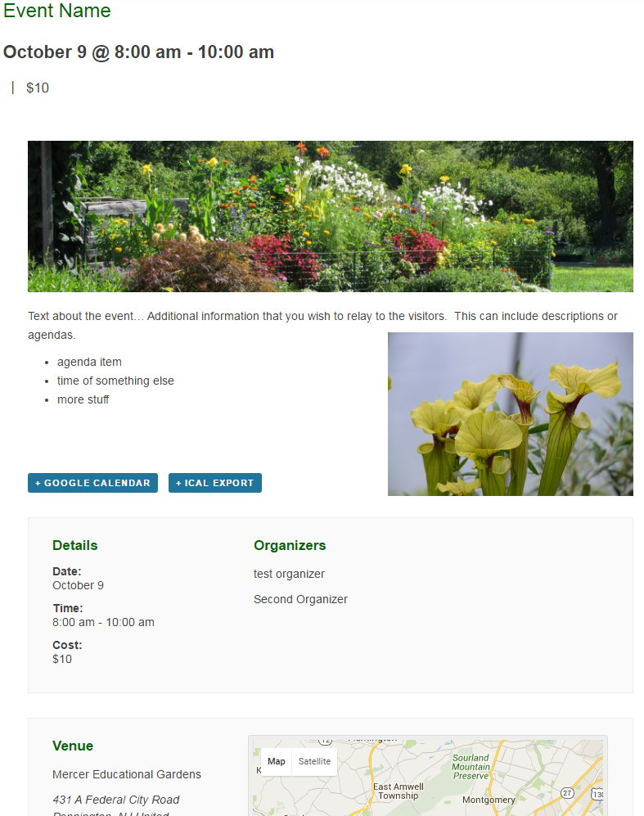 | The Event Name, date and time (cost is optional)  The Featured Image will display on the Event list as well as the Event details page.  - Recommended with is 1600 pixels.  - Recommended height is not more than 800 pixels  Below the “Featured Image” a description area allows for formatted text and additional pictures.  Organizers can optionally be listed if a contact is needed.  Providing a venue name and address will enable Google Maps to display.

Information Type | Enter Details Here
Add New Event
Enter title here
Featured Media file  This file will be displayed in the event listing and at the top of the event details.  (Insert as an object, or attach to email) | Recommended size: 1600 wide X 800 tall
Additional Media or graphics
This file will be displayed with the event details.
(Insert as an object or attach to email)
Descriptive Text to display in event details section
TIME & DATE
All Day Event: Yes/No
Start Date & Time:
End Date & Time:
LOCATION
Venue Name:
Address:
City:
Country:
State or Province:
Postal Code:
Phone:
Website:
ORGANIZERS
Organizer Name:
Phone:
Email:
Add another organizer
Organizer Name:
Phone:
Email:
EVENT WEBSITE
URL: (Enter a word for easy access-- example.com)
EVENT COST
Cost: (Enter cost to public)
FEATURED EVENT FOR THE MONTH
Enter Yes if this is a featured event and should always be listed as the first monthly event for the month scheduled.

Additional Comments:

